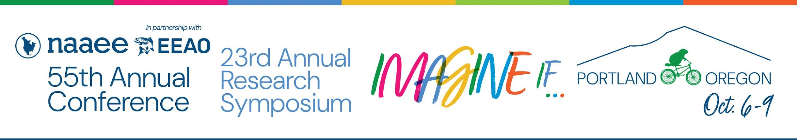

NAAEE Annual Research Symposium
2026 Draft Proposal Form
Proposals Due by: April 10, 2026

Before completing your proposal, please be sure to read the Annual Research Symposium Call for Presentations, which describes what reviewers are looking for this year, and explains many of the options below.
Completing this form is optional. To streamline your online submission process, you can draft your proposal using this form, save it on your computer, and transfer (copy and paste) the information to the online submission form. Proposals must be submitted online.

To use this form, click INSIDE the gray boxes
and type your text.

Tips for Preparing Your Proposal
- The Research Symposium encourages proposals about in-progress research projects or discussion related to the research process.
- Be innovative and creative! This is a competitive process and reviewers are looking for sessions that will push our collective thinking about environmental education.
- Provide enough detail to give reviewers a clear picture of what will happen in your session.
- Avoid abbreviations and acronyms, which may not be familiar to reviewers or conference participants.
- Comply with word limits. NAAEE reserves the right to edit your entries for length or clarity.

Session Formats
Format
Select the most appropriate format for your proposal. All sessions will be presented at our in-person gathering in Portland; the length and structure vary by format. Individual Presentation Submissions are paired and presented together as a single 40-minute time slot.

Individual Presentation Submissions:
Research Presentation (15 minutes)

Session Submissions:
Research Panel (60 minutes)
Research Roundtable (40 minutes)
Research Workshops (90 minutes)
Research Poster

Information About Your Proposed Session
Title
- Your title should clearly describe your session and is limited to 10 words.
- Use Book Title Style (uppercase first letters for principal words). Please do not enter your title in all caps.
- NAAEE may edit your title for length or clarity.

➜ Click inside the gray box to enter your title:

Summary
- This summary is your "marketing pitch" for your session and is limited to 50 words.
- Use clear and engaging language that will attract participants to your session.
- Research posters may share findings from completed research; presentations, panels, and roundtables should focus on discourse of broader questions of research process or impact, and workshops should provide guidance on research practice.
- Only this summary will be included in the research symposium program if your proposed session is selected.
- NAAEE may edit your summary for length or clarity.

➜ Click inside the gray box to enter your summary:

Description
- This description should elaborate on your 50-word summary and is limited to 500 words.
- Descriptions for discussion formats and workshops should describe the proposed topic for discussion, describe the perspectives presenters bring to the topic, and briefly cite research literatures that inform the topic.
- Reviewers use this description to evaluate your proposed session compared to the criteria detailed in the Call for Presentations.
- Address each criterion in your session description, providing enough detail for reviewers to fully understand your plans.
- This description is used only by reviewers and is not included in the research symposium program.

➜ Click inside the gray box to enter your description:

Keywords
Select up to three of the following keywords for your proposed session. Conference participants will be able to search the mobile app for these tags.
Adult education
Arts
Civic engagement
Climate change education
Early childhood
Elementary school programs
Gardening and food systems
Graduate student research
International EE
Justice, equity, diversity, inclusion, and accessibility
Leadership and capacity building
Middle & high school programs
NGSS/Common Core
Spirituality
STEM
Traditional knowledge
Underserved audiences
University programs
Young professionals
Presenter Information
Your name should now be listed as a presenter in the table below. To add presenters, follow the instructions under "Add/Search for Presenters by Last Name" (below).
- Presenters and moderators are automatically listed alphabetically in our program app.
- All presenters and moderators listed here must register for the conference or research symposium by August 21. Because NAAEE is a nonprofit organization dependent on conference registration fees, there are no registration waivers or discounts for presenters.
- To recognize contributors to your work who are not attending the conference or research symposium, select the “non-attending contributor” role.
- If you are the session contact but not a presenter, you must add at least one presenter before removing yourself from the presenter table.

Step 1. Add/Search for presenters by last name.
- Enter the new presenter's last name in the search box on the right. If the individual already has an All Academic profile, the name, email address, and affiliation will appear in a new table below. Select "Add" in the "Action" field to add the individual to your list of presenters.
- If no match appears, create an All Academic profile for the individual. Click on "Add Unlisted Participant" at the bottom of the page. Add the name, email address, and affiliation. The system will generate a username and password, and the individual will receive a notification email.
- The added presenter will appear in your presenter list immediately.
- Repeat this process for each person you wish to add to your proposal.
- To acknowledge contributors who are not attending the conference, follow the same procedures as above, selecting non-attending contributor as the role.

Step 2. Accept and continue.
- When your session is fully populated, click “Accept and Continue.”
➜ Click inside the gray boxes to enter each presenter and identify their role.

Name:
Affiliation:
Email Address:
(Note: Use the same email address here and for conference registration.)
Role (Check One):
Presenter
Moderator
Non-Attending Contributor

Name:
Affiliation:
Email Address:
(Note: Use the same email address here and for conference registration.)
Role (Check One):
Presenter
Moderator
Non-Attending Contributor
Name:
Affiliation:
Email Address:
(Note: Use the same email address here and for conference registration.)
Role (Check One):
Presenter
Moderator
Non-Attending Contributor

Name:
Affiliation:
Email Address:
(Note: Use the same email address here and for conference registration.)
Role (Check One):
Presenter
Moderator
Non-Attending Contributor

Name:
Affiliation:
Email Address:
(Note: Use the same email address here and for conference registration.)
Role (Check One):
Presenter
Moderator
Non-Attending Contributor

