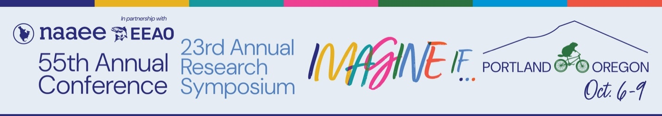

2026 REGISTRATION RATES

2026 ANNUAL CONFERENCE
Full Registration Member $595
Early Bird by 8/21/26 $550
Full Registration Nonmember $715
Early Bird by 8/21/26 $670
One-Day (Wednesday/Thursday/Friday, limit of one purchase) $250
Early Bird by 8/21/26 $225

2026 RESEARCH SYMPOSIUM
Research Symposium Member $355
Early Bird by 8/21/26 $330
Research Symposium Nonmember $400
Early Bird by 8/21/26 $375

2026 CONFERENCE AND RESEARCH SYMPOSIUM BUNDLE — SAVE!
Member Bundle $780
Nonmember Bundle $925

Students (with ID): 20% discount
Retired: 20% discount

- Conference tickets include access to the Tuesday evening opening reception and plenary, all concurrent and plenary sessions Wednesday through Friday, the Wednesday exhibit luncheon, the Thursday closing celebration at the Oregon Museum of Science and Industry (transportation included), and the Friday awards luncheon. There is also one mid-morning coffee break each day.
- One-day tickets include access to all concurrent sessions, the plenary session, the mid-morning coffee break, and any reception or meal scheduled that day.
- Research Symposium tickets include access to all concurrent and plenary sessions on Tuesday and Wednesday, the Research Symposium luncheon and the Conference opening reception on Tuesday, and the exhibit luncheon on Wednesday. There is also one mid-morning coffee break each day.
- Bundle tickets include all of the above.

Click here for more information on scholarships and financial aid.

